Point Cloud

Its basically a raw 3D scan. They are filtered to extract certain attributes.

_____________________________________________________________________________

It is the simplest form of a 3D model. Its a collection of individual points plotted in 3D space.
Each points contain certain measurements (x,y,z / r,g,b / luminance value).

It is created by performing a scan of an object using either a LiDAR (sends out pulses of light to the surface of an object and measuring how long it takes each pulse to reflect back and hit the scanner) or photogrammetry (process of creating measurements from pictures, it uses photos of an object taking at a different locations to triangulate points on the object and plot these points in 3D space).

The primary purpose of a point cloud is to create a 3D model.
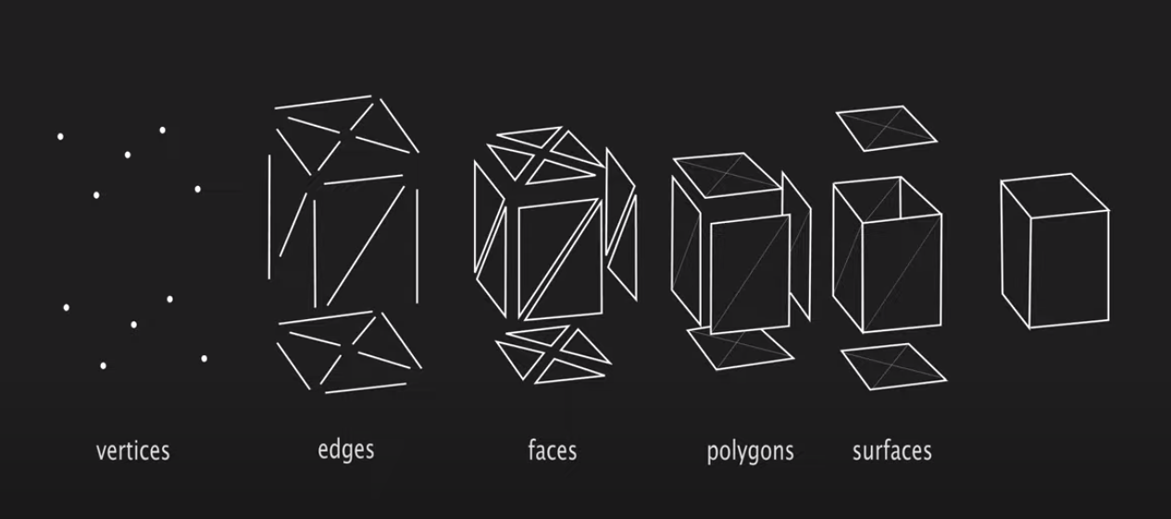
Often the point data is first converted into a polygon mesh. This is because most 3D modeling software programs work with polygons.

